**Testing:**

testing is a process of identifying the correctness of software by considering its all attributes and evaluating the execution of software components to find the software bugs or errors or defects.

**Error /Mistake :**  human action that produces an incorrect result.

**bug:** the process using which we correct the bugs that we found during the testing process.

**Fault**:a state that causes the software to fail to accomplish its essential function.

**Failure** :the combination of various defects that leads to hardware and software failure resulting in an unresponsive system.

**defect** :A defect is an error or a bug, in the application which is created

**BUG LIFE CYCLE:**

**BUG LIFE CYCLE**

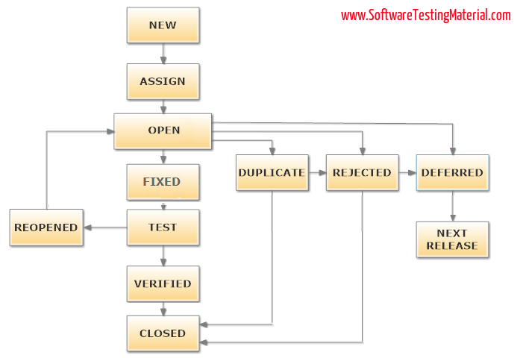



**1. New**

When a tester finds a new defect. He should provide a proper Defect document to the Development team to reproduce and fix the defect. In this state, the status of the defect posted by the tester is “New”

**2. Assigned**

Defects that are in the status of New will be approved (if valid) and assigned to the development team by Test Lead/Project Lead/Project Manager. Once the defect is assigned then the status of the bug changes to “Assigned”

**3. Open**

The development team starts analyzing and works on the defect fix

**4. Fixed**

When a developer makes the necessary code change and verifies the change, then the status of the bug will be changed as “Fixed” and the bug is passed to the testing team.

**5. Test**

If the status is “Test”, it means the defect is fixed and ready to do test whether it is fixed or not.

**6. Verified**

The tester re-tests the bug after it got fixed by the developer. If there is no bug detected in the software, then the bug is fixed and the status assigned is “verified.”

**7. Closed**

After verified the fix, if the bug is no longer exits then the status of the bug will be assigned as “Closed.”

**8. Reopen**

If the defect remains the same after the retest, then the tester posts the defect using the defect retesting document and changes the status to “Reopen”. Again the bug goes through the life cycle to be fixed.

**9. Duplicate**

If the defect is repeated twice or the defect corresponds to the same concept of the bug, the status is changed to “duplicate” by the development team.

**10. Deferred**

In some cases, the Project Manager/Lead may set the bug status as deferred.

* If the bug found during the end of the release and the bug is minor or not important to fix immediately.
* If the bug is not related to the current build.
* If it is expected to get fixed in the next release.
* The customer is thinking to change the requirement.
* In such cases the status will be changed as “deferred” and it will be fixed in the next release.

**11. Rejected**

If the system is working according to specifications and the bug is just due to some misinterpretation (such as referring to old requirements or extra features) then the Team lead or developers can mark such bugs as “Rejected”